Task on Load Balancers
- Configure Classic Load balancer.
Objective:
To create and configure a Classic Load Balancer (CLB) in AWS and distribute incoming traffic across multiple EC2 instances to improve application availability and fault tolerance.
Purpose:
To distribute client requests across multiple EC2 instances
To improve application availability and reliability
To prevent a single server from becoming overloaded
Steps:
    - Created a My-ec2-CLB1 ec2 instance with Ami Linux, existing key_pair VPC as My-VPC-ASG subnet as My-Pub-Subnet-ASG of us-east-1a with default security group & in boot strap added a bash script to install httpd deploying a index.html file
    - Checked the status of httpd with the public ipv4
    - Created a My-ec2-CLB2 ec2 instance with Ami Linux, existing key_pair VPC as My-VPC-ASG subnet as My-Pub-2-Subnet-ASG with default security group & in boot strap added a bash script to install httpd deploying a index.html file
    - Checked the status of httpd with the public ipv4
    - Created a Classic Load balancer, My-CLB selecting the VPC, My-VPC-ASG subnets, My-pub-subnet-ASG & My-pub-2-subnet-ASG with adding the two instances, My-ec2-CLB1 & My-ec2-CLB2, Listener HTTP as 80 & instance HTTP as 80
    - Check the ping target as /index.html & target instances health as in-service
    - Check with DNS name & the CLB will work as expected.
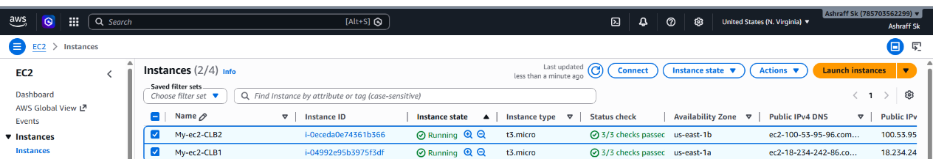
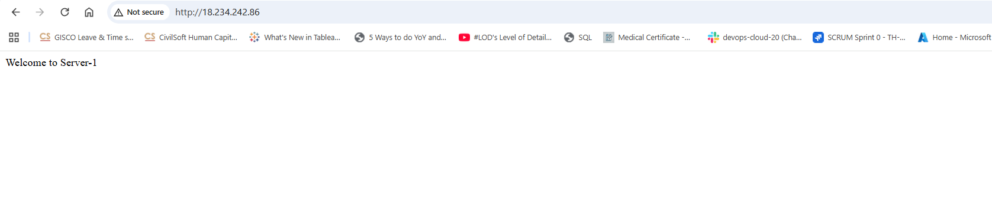
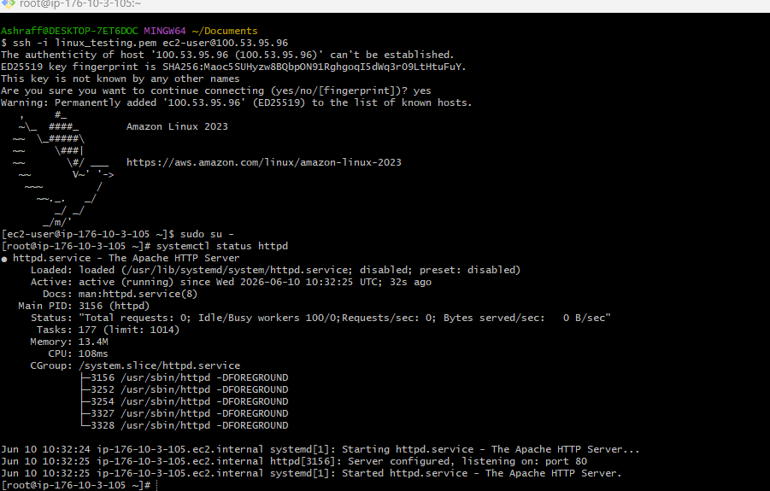
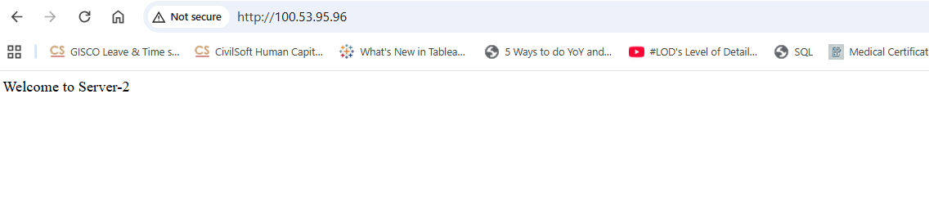
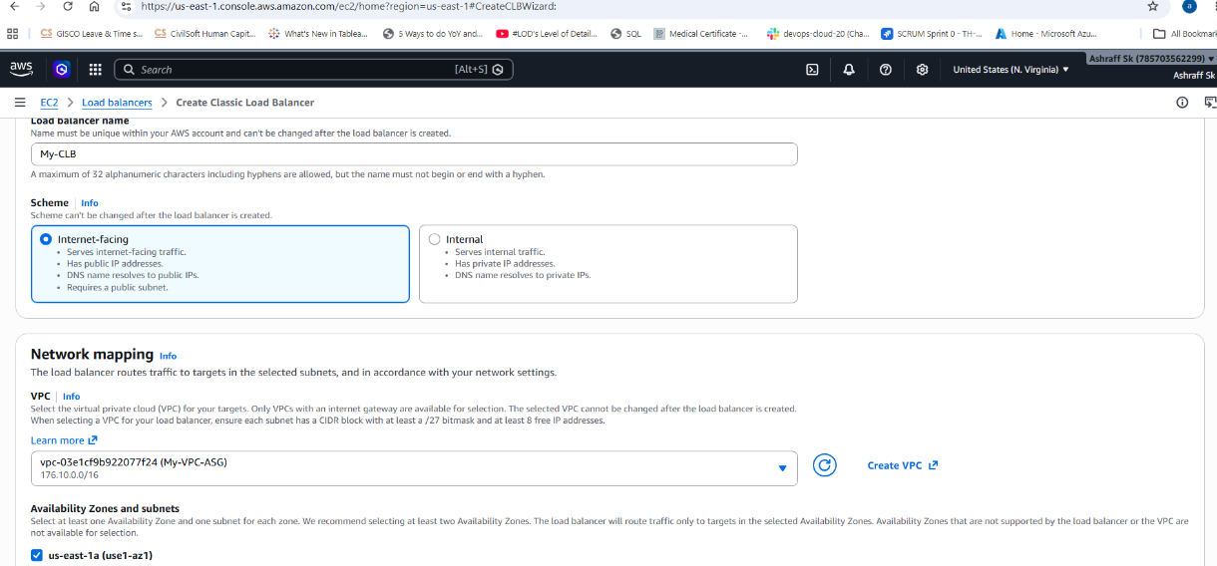
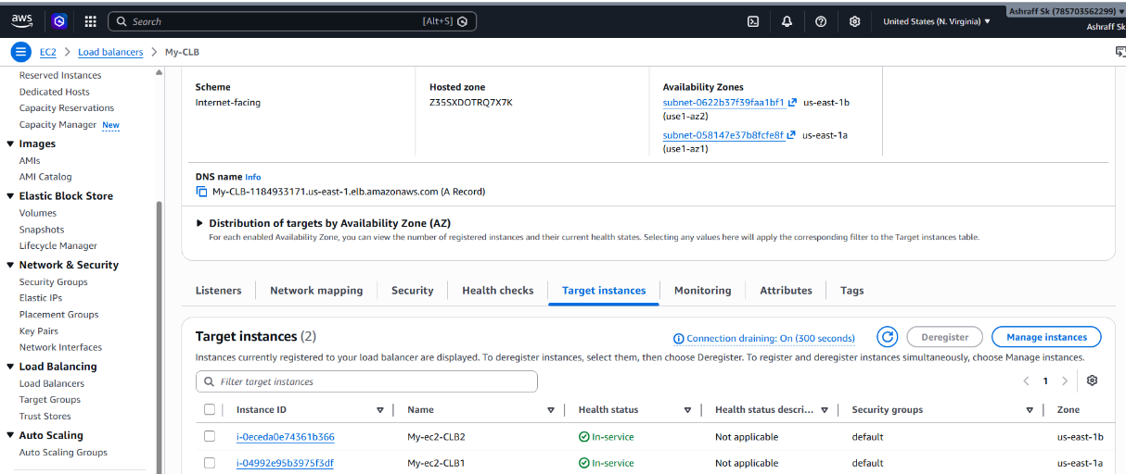
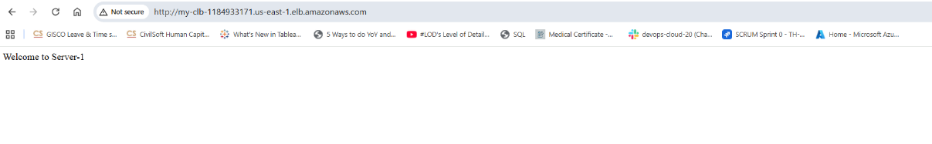
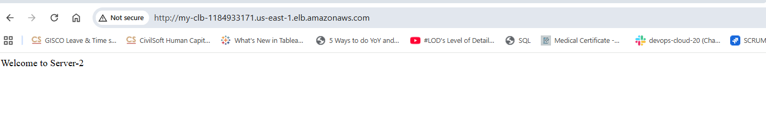
Conclusion:
A Classic Load Balancer (CLB) was successfully configured and attached to multiple EC2 instances. The CLB distributes incoming traffic across healthy instances, improves application availability, and provides fault tolerance by automatically routing traffic away from unhealthy instances. It is suitable for legacy applications that require basic load balancing functionality
Use Cases:
1. Legacy Applications
Older web applications requiring basic load balancing
2. Small Web Applications
Simple HTTP/HTTPS traffic distribution
3. Lift-and-Shift Migrations
Moving traditional applications to AWS
4. High Availability
Multiple EC2 instances behind one endpoint

- Configure Application Load balancer.

Objective:
To create and configure an Application Load Balancer (ALB) that distributes incoming HTTP/HTTPS traffic across multiple EC2 instances, ensuring high availability, scalability, and fault tolerance.
Purpose:
To distribute incoming user traffic across multiple EC2 instances
To improve application availability and reliability
To automatically route traffic to healthy servers
To support modern web applications and microservices
To provide Layer 7 (HTTP/HTTPS) load balancing capabilities
Steps:
Step 1: Create Target Group
A target group tells the load balancer where to send traffic.
1. Go to EC2 Dashboard
2. Click Target Groups (left panel)
3. Click Create target group
4. Choose:
Target type → Instances
Protocol → HTTP
Port → 80
VPC → same as your EC2 instances
5. Click Next
6. Select both EC2 instances
7. Click Include as pending
8. Click Create target group as ALB-TG
Step 2: Create Application Load Balancer
1. Go to Load Balancers
2. Click Create Load Balancer
3. Choosen as Application Load Balancer
4. Configure:
Name: ALB-01
Scheme: Internet-facing
IP type: IPv4
VPC: same as EC2
Subnets: select at least 2 Availability Zones (important)
5. Security Group: Allow HTTP (80) inbound
6. Listeners as HTTP : 80

Step 3: Attach Target Group
1. In Listeners section
2. Choose Forward to target group
3. Select the target group you created earlier
4. Click Create Load Balancer
Step 4: Verify Health Check
1. Go to Target Groups
2. Open your target group
3. Check Targets tab
Status should show: healthy
If unhealthy:
• Check security group (port 80 open)
• Ensure web server is running on EC2
Step 5: Test Load Balancer
1. Copy DNS name of ALB
2. Paste in browser:
http://<alb-dns-name>
3. Refresh multiple times

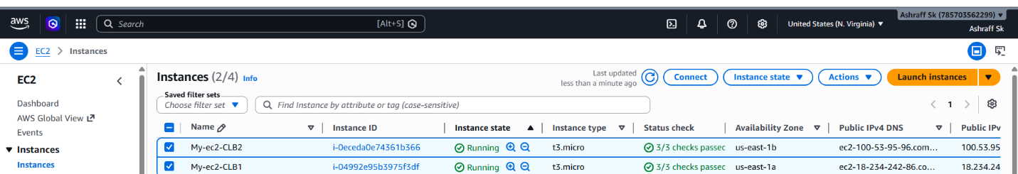



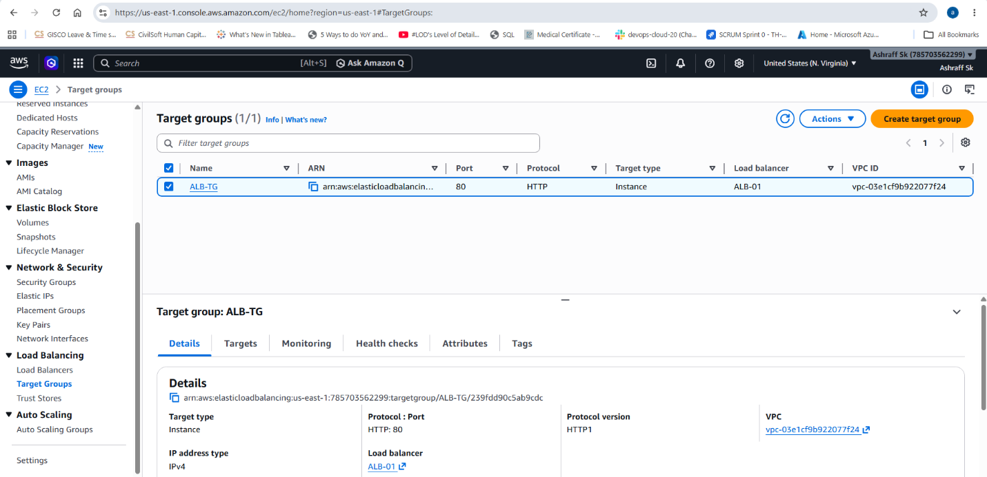
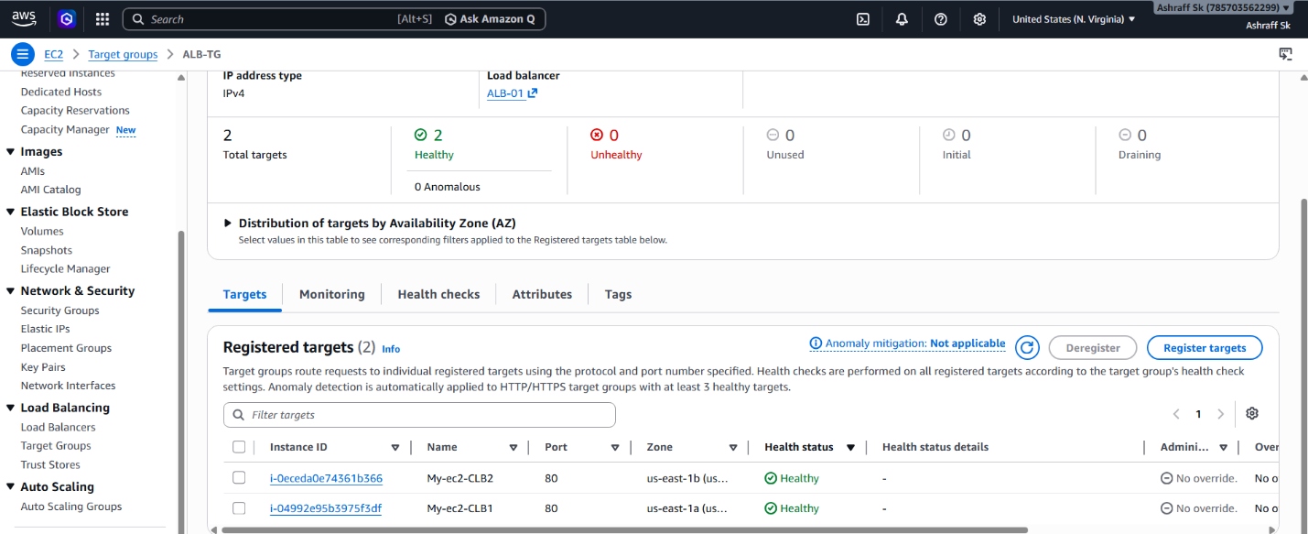
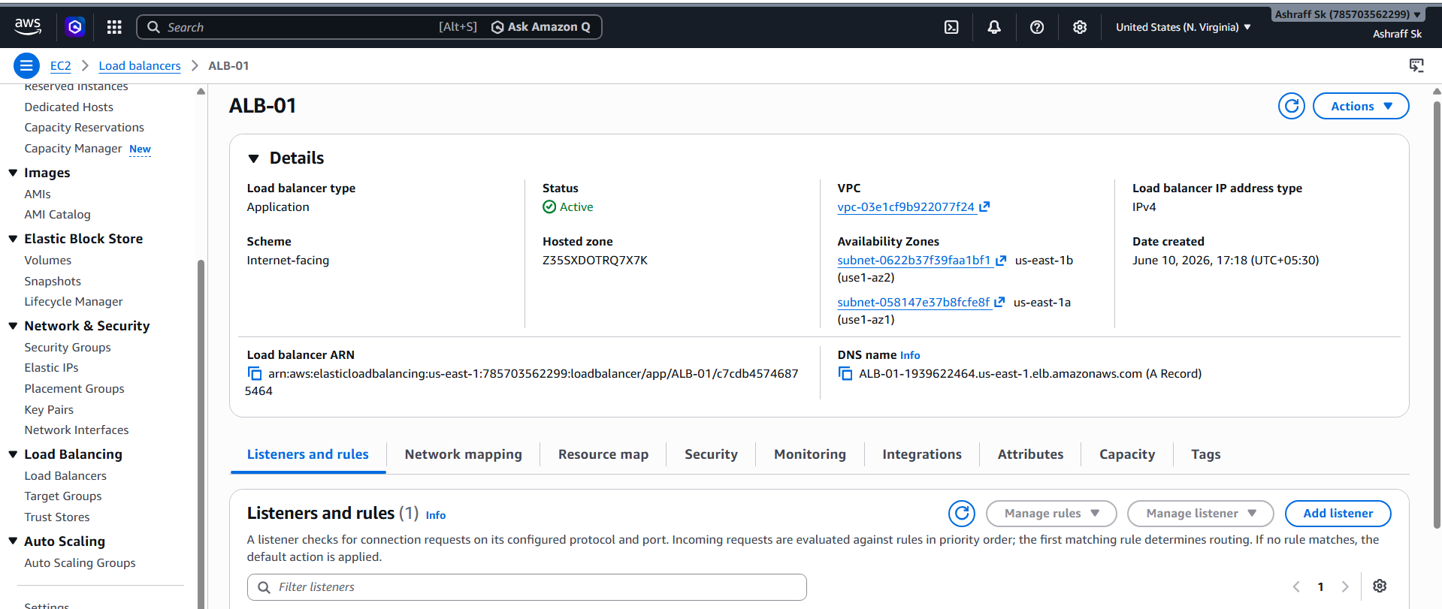
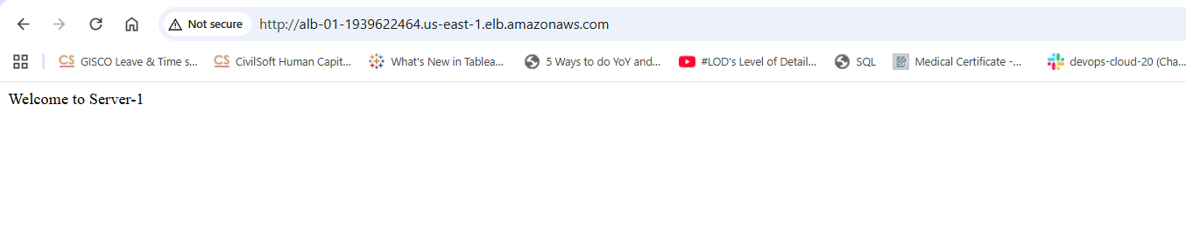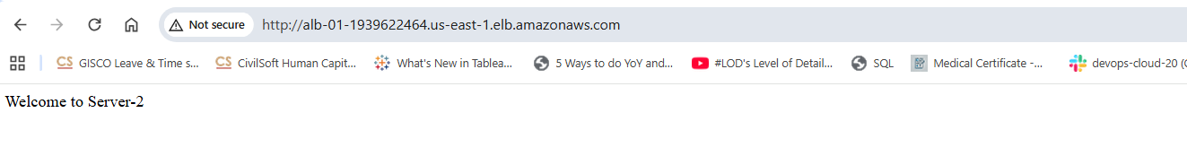

- Configure Network Load balancer.
Objective:
To distribute TCP/UDP traffic across multiple EC2 instances using a Network Load Balancer (NLB) and provide high availability and fault tolerance.
Purpose:
Handle millions of requests with very low latency.
Route TCP, UDP, and TLS traffic.
Provide static IP addresses.
Support high-performance applications.
Steps:
- Launch two EC2 Instances, My-ec2-CLB1 with public Ipv4 as 18.234.242.86 & My-ec2-CLB2 with public Ipv4 as 100.53.95.96
- In the EC2 console, go to load balancers and create a new load balancer.
- It will show different types of load balancers, in that we have select Network load balancer.
- Create a target group with the instances.
- In the Network load balancer, we have to give the protocol as TCP and port number will be 22.
- Created target group will be added in the load balancer.
- Click on create load balancer and it will create a DNS url.
- With that URL, we have to ssh the instance.
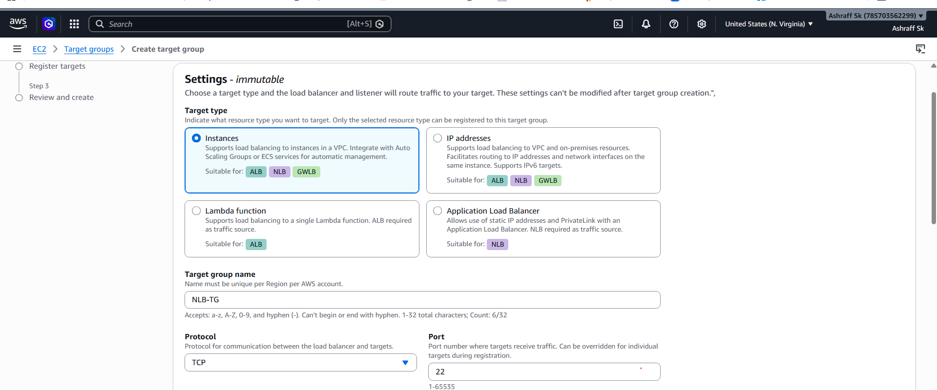
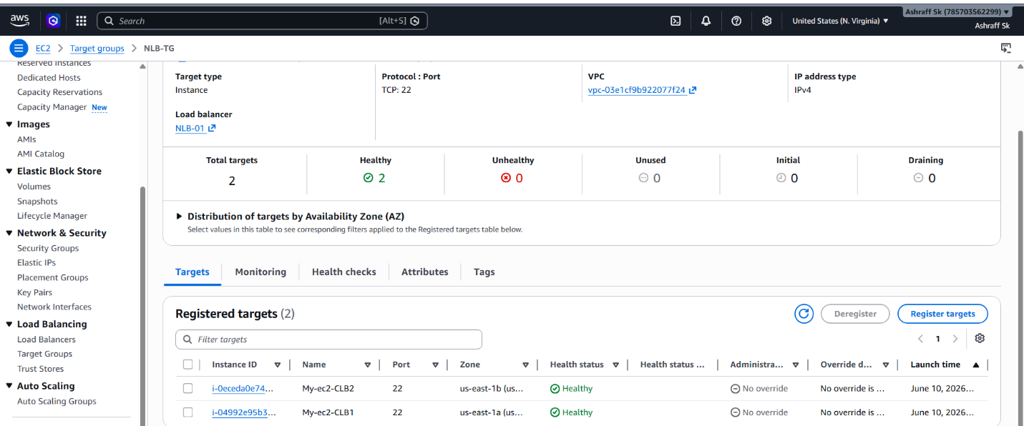
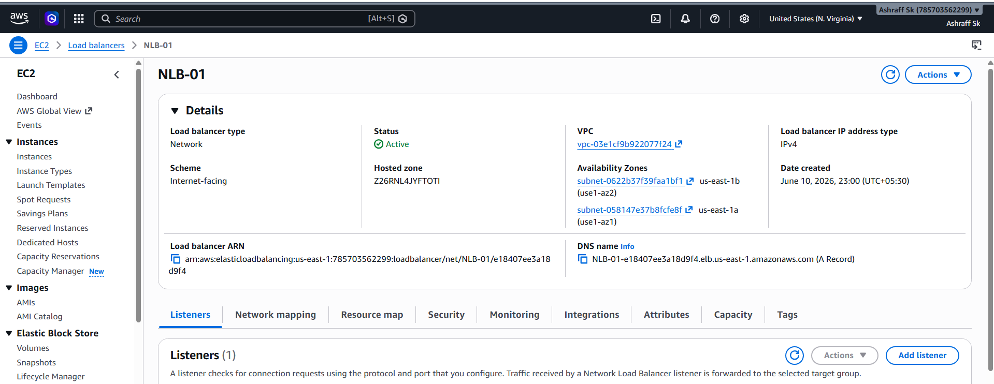
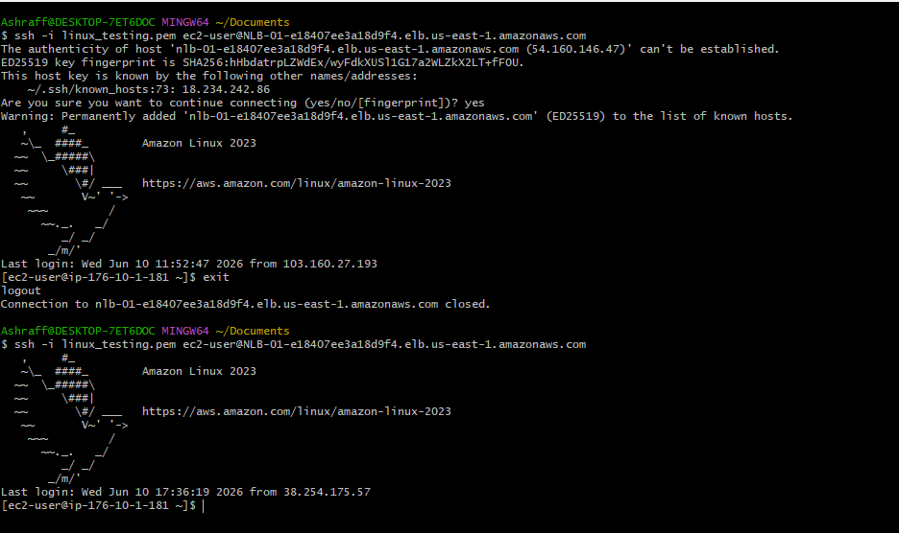

- Attach SSL for application load balancer.

Steps:
- Create a SSL certificate and after requesting the
certificate it will show as pending validation.
- To get validation approved, go to Route53 and there will get CNAME record.
- And edit that record as A record and enable the alias option and in that alias option we have to redirect the traffic to application load balancer.
- Now go to load balancer, changes the listener from HTTP to HTTPS as the SSL certificate will validate the https requests only.
- When we change the listener to HTTPS then it will ask us to attach the SSL certificate & we have to attach our SSL certificate
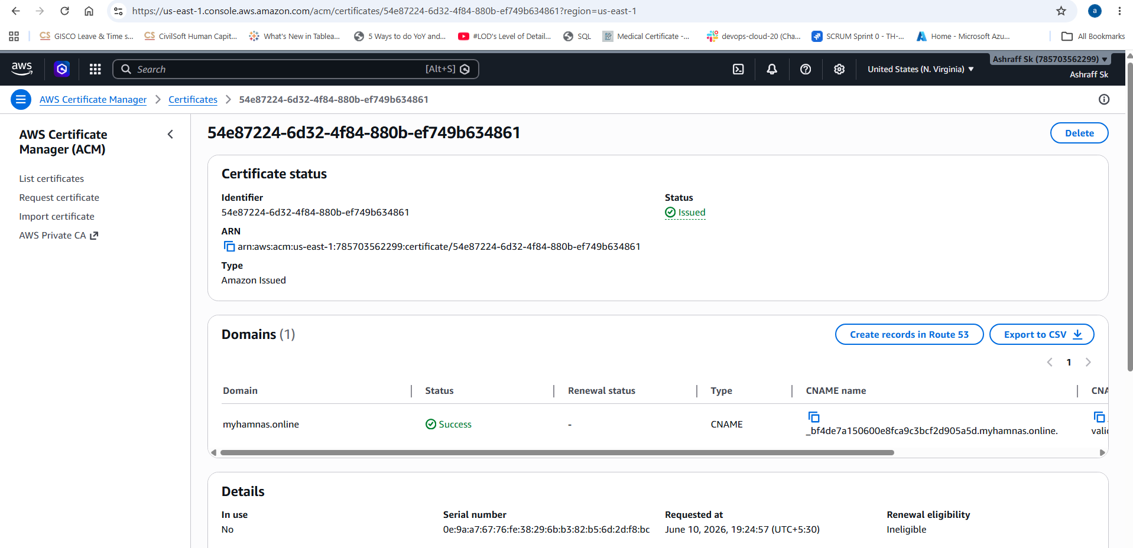
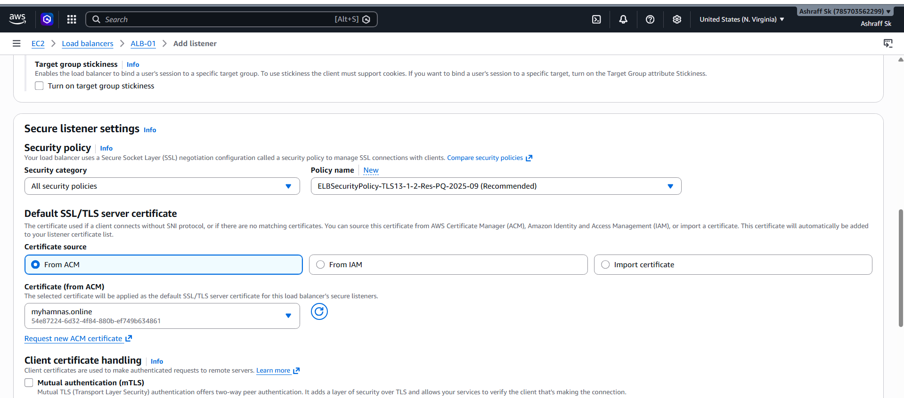

- Map Application load balancer to R53.
Purpose:
The purpose of mapping an Application Load
Balancer to Route 53 is to your application accessible through a custom domain name while leveraging the ALB's load balancing,
scalability, and high-availability features.
Objective:
The primary objective of mapping an Application Load Balancer to Amazon Route 53 is to enable users to access an application through a custom domain name while ensuring reliable, scalable and highly available traffic routing.
Steps:
Go to load balancer, changes the listener from HTTP to HTTPS because the SSL certificate will validate the https requests only.
When we change the listener to HTTPS then it will ask us to attach the SSL certificate, that’s where we have to attach our SSL certificate.
By SSL certificate attaching in the load balancer only, we can connect to the Route53.

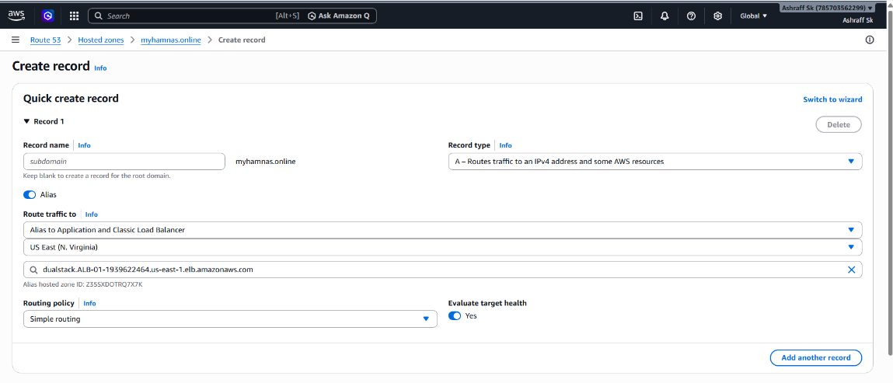
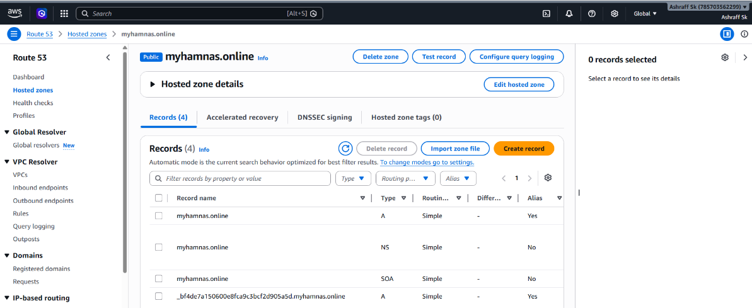
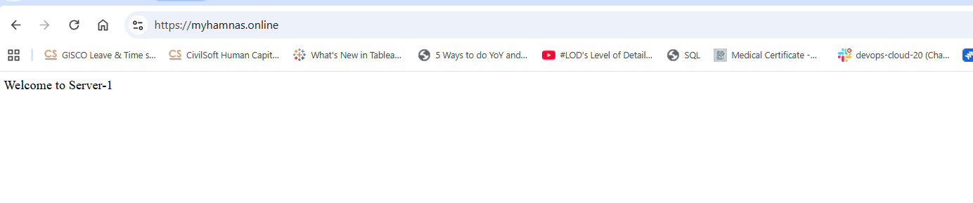
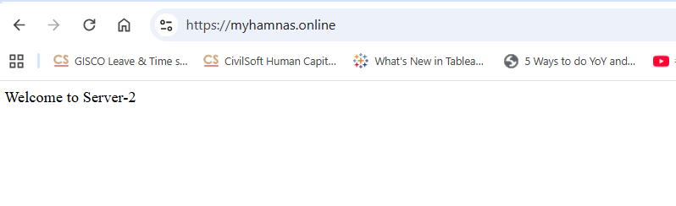

- Push the application load balancer logs to S3.
Purpose:
The purpose of sending Application Load Balancer
access logs to an Amazon S3 bucket is to store detailed records of incoming requests for monitoring, troubleshooting, security
analysis, auditing and reporting.

Steps:
- Create a S3 bucket to store our logs and add a bucket policy to get permissions to communicate with the Application Load Balancer.
- In the load balancer, go to Attributes tab and there you can see access logs.
- The access logs, we have to enable and it will ask for a S3 bucket
